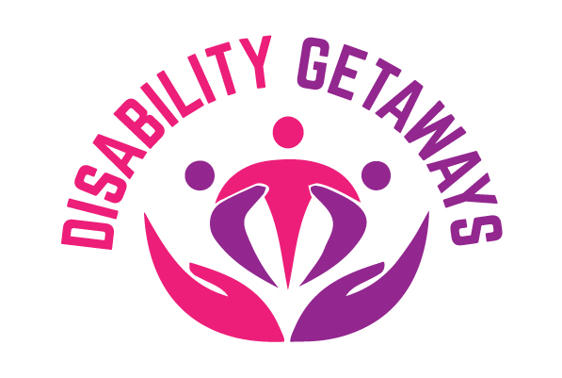

**Ways to contact DISABILITY GETAWAYS - Easy English**



If you want to let us know something, you can:



Talk to us



Call Manager on 0403905480

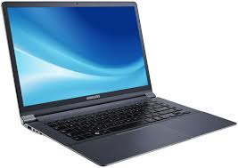

OR you can go to the Disability Getaways website and complete a complaints & feedback form

OR email us at contact@disabilitygetaways.com

**Disability Getaways will……………………..**



Listen to you



Be Be respectful to you



And help you