DISABILITY GETAWAYS CONSENT TO SHARE INFORMATION This is consent to share information form

You’re Name: _________________

Consent means you say yes.

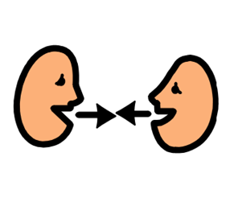

Can we talk to other people about you?

Please circle Yes or No
Yes | No | People we can share info with | Details
 |  | Your Medical practitioner
 |  | Health Specialist-
 |  | Health Specialist
 |  | Allied health practitioner
 |  | Disability Services SA
 |  | NDIA
 |  | Public Trustee
 |  | Bank
 |  | Family and friends
 |  | Other
This is important:

Your information might be shared with others if we think you or others are not safe.

PLEASE PUT A CIRCLE AROUND YOUR ANSWER

Yes | No
 |  | Home Place service has been explained to me.
 |  | A Home Place worker has explained to me why information may need to be shared with others for safety
 |  | Home Place can get information important to providing a support service to me.

Sharing of information may include
Writing about you

RReading information about you

Talking to someone about you
Participant’s Name :______________________
Signed:______________________
Date: ________________
Verbal consent

I have discussed consent and safety with

Name of Participant:__________________

I am satisfied that they understand about information sharing and I believe they have given informed consent.

Disability Getaways staff member:
:

Name:________________________
Signature:_____________________
Date:_________________________

Consent declined

Consent was declined because:

Disability Getaways staff member:

Name:________________________
Signature:_____________________
Date:_________________________

